How Malak Mattar’s Paintings Became a Voice for Palestine
Marianne Cederberg
20.12.2024
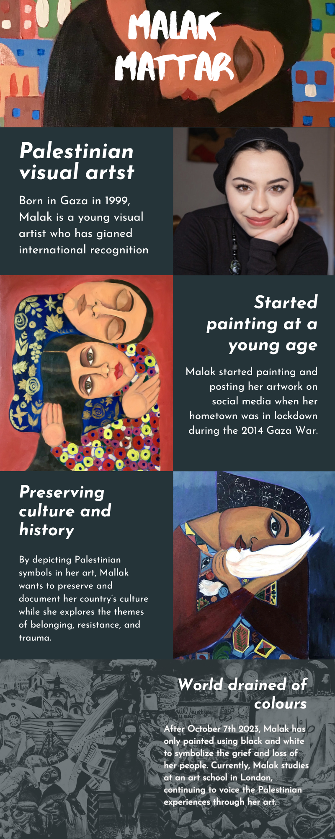
Malak Mattar is a London-based Palestinian visual artist whose powerful work has gained international recognition. Born in Gaza in 1999, Malak uses her art to explore themes of identity, war, and belonging, offering a deeply personal perspective in capturing the Palestinian experience. Her bold, expressive paintings have drawn comparisons to artists like Frida Kahlo and Picasso, coming together in a style that remains uniquely hers.
Malak grew up in Gaza where her family had moved as refugees in 1948. She started painting at the age of 15 when her hometown was in a lockdown during an Israeli offensive. Painting became her escape: it allowed her to process the trauma and express her emotions. Her talent did not go unnoticed and quickly after she started posting her art on social media, she was already selling her artwork. Now, her artwork has been exhibited in over 80 countries.
The ongoing conflict in Palestine has profoundly impacted Malak’s art. In 2023, she made a radical shift in her artistic approach: when the genocidal war began in Palestine, Malak started painting only in black and white to symbolize the grief and loss of her people.
Beyond painting, Malak’s work also includes storytelling. In 2022, Malak authored and illustrated a children’s book titled Sitti’s Bird: A Gaza Story. The book tells the story of a young girl growing up in the shadow of war, her dreams symbolized by a bird. Malak has also organized workshops where children around the world wrote letters to those in Palestine.
Malak’s art stands as a testament to her people, using creativity as a form of resistance and cultural preservation. As a Gen-Z artist, Malak has also been active on social media in advocating for Palestinian solidarity and resistance. More of her work can be found on Instagram at @malakmattarart.

